DBMS Storage Cheatsheet

1. Storage Hierarchy
Level | Description | Speed | Volatility | Granularity
Primary Storage | Main memory (RAM), CPU cache | Very fast (~50 GB/s, ~100ns latency) | Volatile | Byte-level
Secondary Storage | HDDs, SSDs | Slower (HDD: ~280 MB/s, 1–30 ms; SSD: ~7 GB/s, 10–100 µs) | Non-volatile | Block-level (e.g., 4 KB)
Tertiary Storage | Magnetic tapes, optical disks | Very slow (manual access, offline) | Non-volatile | Bulk archival

2. SSD vs HDD
Aspect | SSD | HDD
Speed | Faster | Slower
Size | Smaller | Larger capacities per drive
Cost | More expensive | Cheaper per TB
Usage | Boot partitions, smaller data sets | Large DB storage, archival
Sales 2020: Similar number of drives sold; HDD capacity ~5× SSD capacity sold.

3. Performance Metrics
- DBMS performance depends on moving data between memory and storage.
- Data must be in primary storage (buffer) for processing.
- Buffers are smaller than databases → frequent data eviction and I/O operations.
- Block-based transfer (e.g., 4KB per I/O).
- Disk I/O is expensive: ~1,000,000 CPU instructions per random I/O.
- Random I/O common unless I/O scheduling is optimized.

4. Good DBMS Algorithm Practices
- Use most of the data in a block when reading it.
- Store related blocks physically close together.
- Keep hot (frequently accessed) blocks in buffer memory.

5. Sorting Large Datasets

Setup Example
- Records: 10⁷ records, 100 bytes each → 10⁹ bytes (1GB).
- Block size: 4 KB → 40 records/block.
- Total: 250,000 blocks.
- Main memory: 50 MB (~12,800 blocks, ~1/20 of the file).
- Goal: Sort file by key.

Merge Sort Basics
- Standard in-memory merge sort is inefficient due to I/O.
- Merge = repeatedly take the smallest “head” record from sorted lists.

Two-Phase Multiway Merge Sort (2PMMS)
Phase 1 – Initial Sorting
- Load as many records as fit in memory.
- Sort in-memory (quick/heap sort).
- Write sorted sublists to disk.
- Repeat until all blocks are processed.
Phase 2 – Merge
- Use (M/B) – 1 buffers for input sublists, 1 buffer for output.
- Merge records by repeatedly picking the smallest current key.
- Write output blocks to disk as they fill.

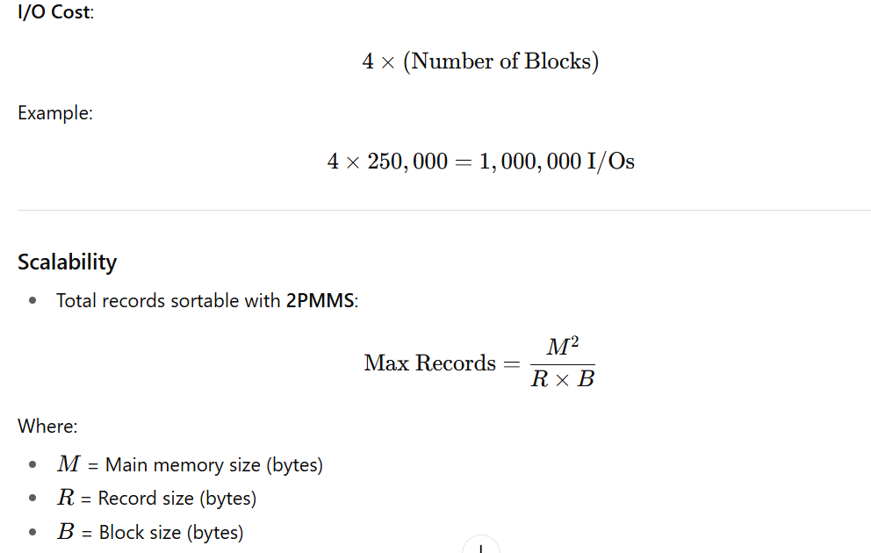

Example:
M=50MB, R=100B, B=4K B→6.71×10^9 records
If data exceeds this limit → add another merge pass (multi-phase merge sort).

6. Key Takeaways
- Optimize I/O, not just CPU usage.
- Block management is critical for efficiency.
- 2PMMS minimizes disk reads/writes during external sorting.
- Larger memory M → fewer passes needed → faster sorting.

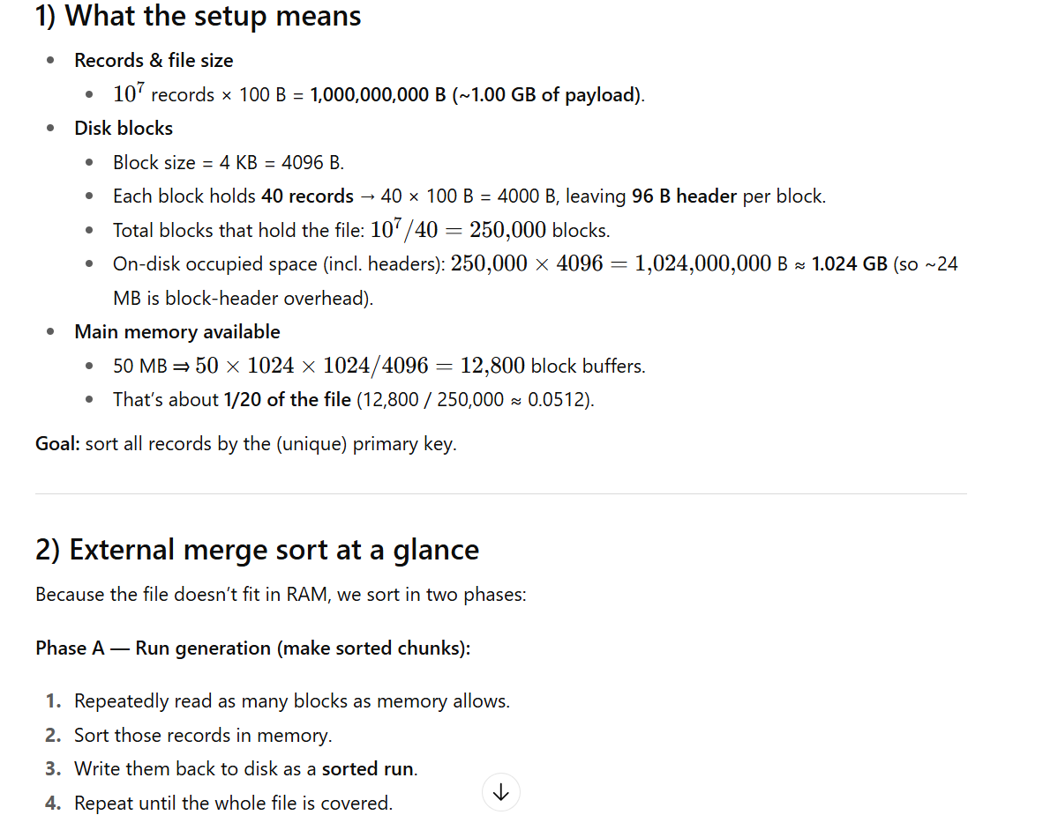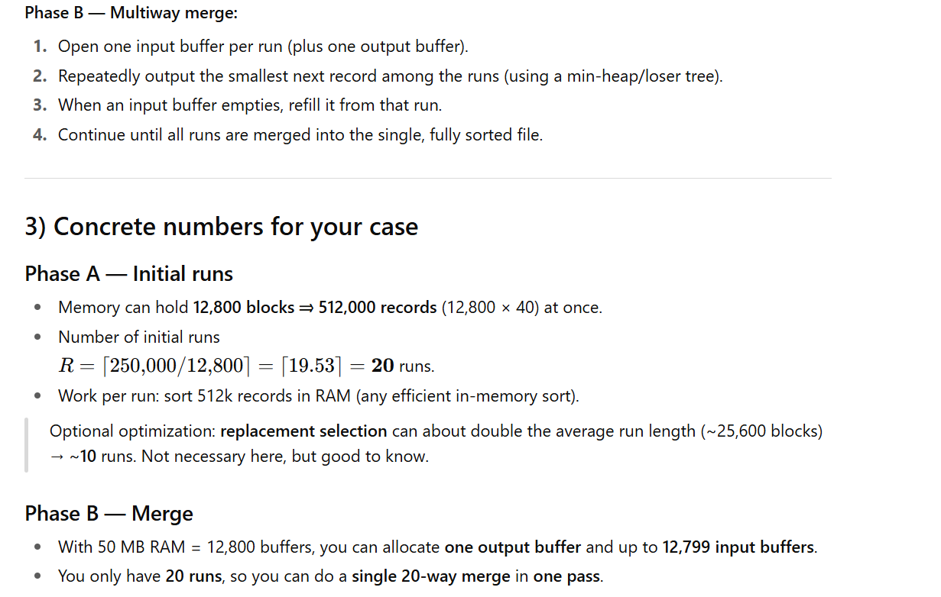
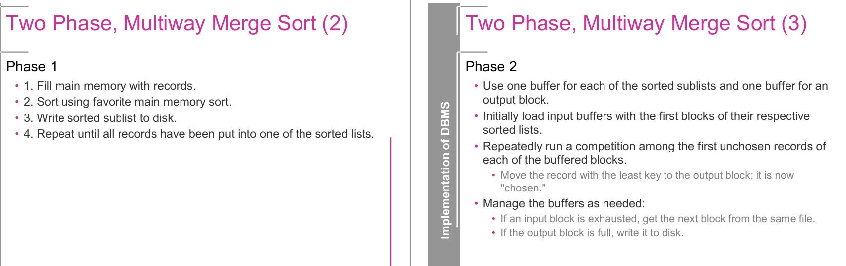

🔹 Concept
Two-Phase Multiway Merge Sort (TPMMS) is an algorithm used by DBMSs to sort very large datasets that do not fit entirely in main memory.
It works in two phases:
- Phase 1: Create sorted runs (in memory and write to disk).
- Phase 2: Merge the runs (multiway merge using buffers).

🔹 Phase 1 (Sorting in Memory and Creating Sorted Sublists)
- Fill main memory with as many records as possible.
- Sort them using an in-memory sorting algorithm (like Quicksort, Heap sort).
- Write the sorted chunk (called a run) to disk.
- Repeat until all records are processed.
👉 After Phase 1, the large dataset is split into several sorted runs on disk.
Example
- Suppose you have 1 GB of data to sort.
- Memory can only hold 100 MB at a time.
- You will read 100 MB, sort it, and write it back → producing 10 sorted runs of 100 MB each.

🔹 Phase 2 (Multiway Merge of Sorted Runs)
- Allocate buffers:
  - One buffer for each run (input buffer).
  - One buffer for the output.
- Load the first block of each run into its input buffer.
- Compare the first unchosen records from all buffers → choose the smallest.
  - Write it to the output buffer.
  - If an input buffer is exhausted, load the next block from that run.
  - If the output buffer is full, write it to disk.
- Continue until all runs are merged into one large sorted file.
Example
- You have 10 sorted runs (from Phase 1).
- You load 10 buffers + 1 output buffer.
- At each step, you select the smallest record among the 10 candidates.
- This way, the final output is fully sorted.

🔹 Why DBMS Uses TPMMS
- Scalability: Handles datasets larger than RAM.
- I/O Efficiency: Minimizes disk reads/writes using block-level operations.
- Foundation for Query Processing: Used in ORDER BY, GROUP BY, DISTINCT, and join algorithms.

🔹 SQL Example
Suppose you run:
SELECT * FROM Employee ORDER BY salary;
If the Employee table has 100 million rows (much bigger than RAM), the DBMS will use TPMMS internally to sort salaries efficiently.

✅ Summary:
- Phase 1: Break data into sorted runs and write to disk.
- Phase 2: Merge runs using multiway merge with input/output buffers.

Phase 1: Create Sorted Runs
Steps:
- Fill main memory with as many records as possible (based on available buffers).
- Sort them in memory using any algorithm (QuickSort, HeapSort, MergeSort).
- Write the sorted sublist (called a run) back to disk.
- Repeat until all records have been processed.
🔹 Example for Phase 1:
- Suppose we have 20 records and memory can hold only 5 records.
- Process:
  - Read first 5 → sort → write to disk as Run 1.
  - Read next 5 → sort → write to disk as Run 2.
  - Repeat → Run 3, Run 4.
- Result: 4 sorted runs, each with 5 records.

Phase 2: Multiway Merge
Steps:
- Use one buffer per run + one buffer for output.
  - Example: If we have 4 runs, we allocate 4 input buffers + 1 output buffer.
- Load the first block from each run into its buffer.
- Competition among first records of each buffer:
  - Choose the smallest key.
  - Write it to the output buffer.
- Manage buffers:
  - If an input buffer is empty → load next block from its run.
  - If output buffer is full → write it to disk.
- Continue until all records are written in sorted order.
🔹 Example for Phase 2 (continuing previous example):
- Runs on disk:
Run 1: [3, 7, 12, 18, 25]
Run 2: [1, 4, 9, 16, 30]
Run 3: [2, 6, 11, 20, 22]
Run 4: [5, 8, 13, 15, 19]
- Merge process:
  - Compare first elements: 3, 1, 2, 5 → smallest = 1 → move to output.
  - Next comparison: 3, 4, 2, 5 → smallest = 2 → move to output.
  - Next comparison: 3, 4, 6, 5 → smallest = 3 → move to output.
  - Continue until output = [1, 2, 3, 4, 5, 6, …, 30].
Final result = one big sorted file.

Key Concepts
- Buffering:
  - One buffer for each input run.
  - One buffer for output.
  - Efficiently manages disk I/O.
- Multiway Merge:
  - Instead of merging 2 runs at a time (like classic MergeSort), TPMMS merges k runs at once (depending on memory).
  - This reduces the number of passes over the data.
- I/O Efficiency:
  - Since database sorting involves huge data, reducing disk reads/writes is critical.
  - TPMMS ensures minimal passes over the data.

Concept with Example
Dataset:
Records: [25, 15, 50, 10, 20, 30, 45, 5, 40, 35]
Memory Capacity: 4 records per load.

Phase 1: Sorting
- Split into chunks: [25, 15, 50, 10], [20, 30, 45, 5], [40, 35]
- Sort each chunk:
  - Chunk 1: [10, 15, 25, 50]
  - Chunk 2: [5, 20, 30, 45]
  - Chunk 3: [35, 40]
- Write sorted chunks to disk: [[10, 15, 25, 50], [5, 20, 30, 45], [35, 40]]

Phase 2: Merging
- Load initial blocks into buffers: [10, 15, 25, 50], [5, 20, 30, 45], [35, 40]
- Compare the smallest records: 5 < 10 < 35. Write 5 to the output buffer.
- Update buffers dynamically:
  - Replace 5 with the next record from its sublist: [10, 15, 25, 50], [20, 30, 45], [35, 40]
- Repeat until all records are merged: [5, 10, 15, 20, 25, 30, 35, 40, 45, 50]

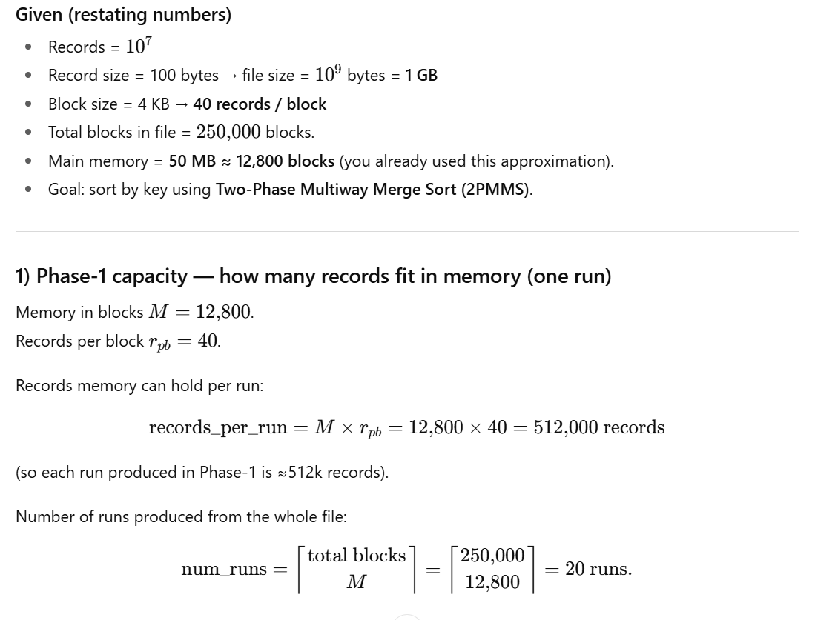

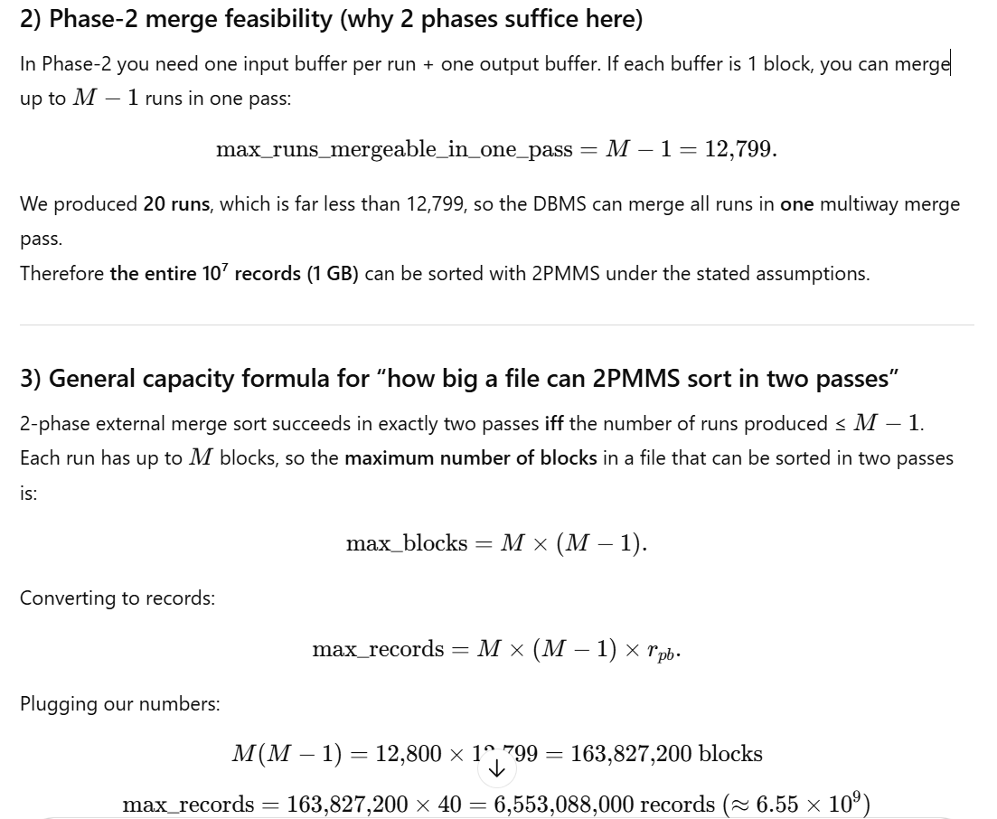
Interpretation: With 50 MB (≈12,800 blocks) memory, 2PMMS can sort up to ~6.55 billion records (~655 GB) in two passes.
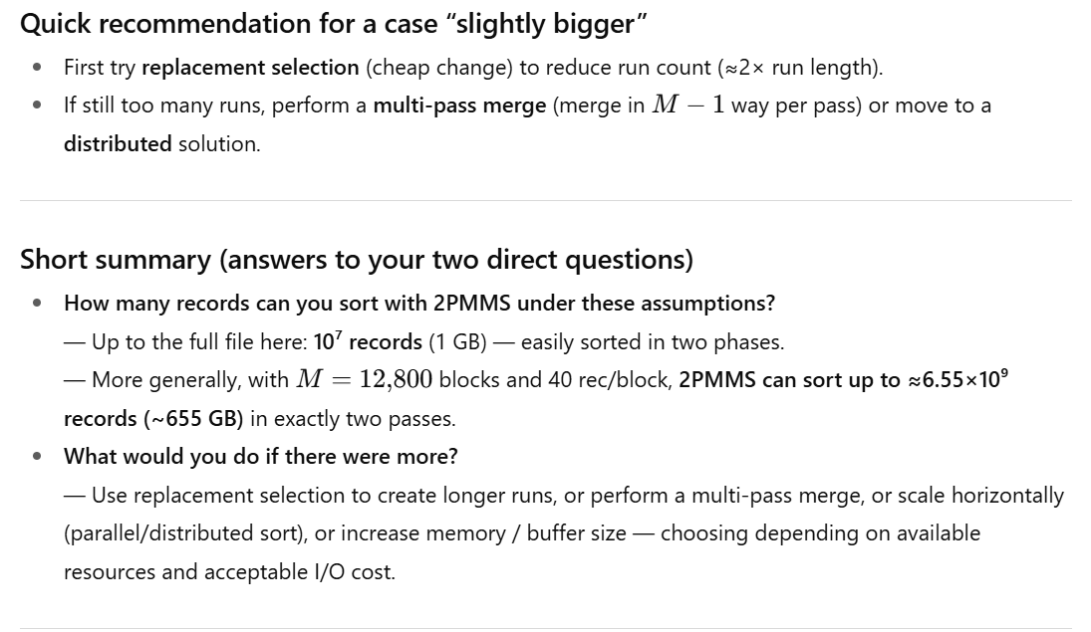

Scalability Question

How Many Records Can Be Sorted Under Given Assumptions?
The number of records that can be sorted depends on the ratio of main memory to the size of the dataset:
- Memory can process 12,800 blocks in one pass.
- With 250,000 blocks, we need approximately 20 batches (passes).
Thus, with 2PMMS, the file size is only limited by the number of passes that the system can handle efficiently. In this case, any dataset up to 20 times the memory size can be sorted efficiently.

What if the Dataset Exceeds Capacity?
If the dataset exceeds this capacity, a multi-phase merge sort can be implemented:
- Add an additional phase (Phase 3) where the sorted output of Phase 2 is treated as the input for another merge step.
- This hierarchical approach allows for sorting larger datasets but increases I/O costs.

Key Takeaways
- Efficient I/O Usage: 2PMMS minimizes I/O operations by dividing data into manageable chunks for memory.
- Scalable for Large Datasets: Limited by the number of passes memory and disk can handle efficiently.
- Extensible for Very Large Datasets: Multi-phase merging allows sorting files far larger than available memory.
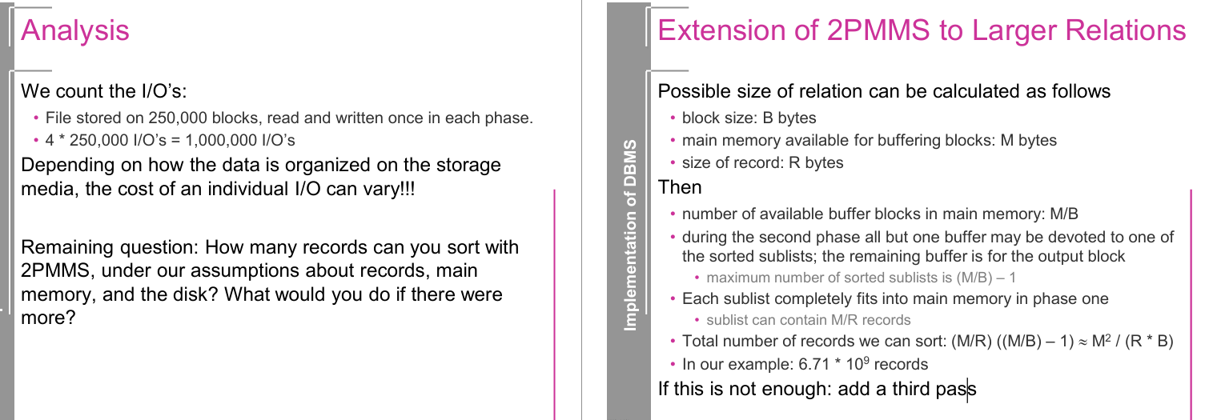
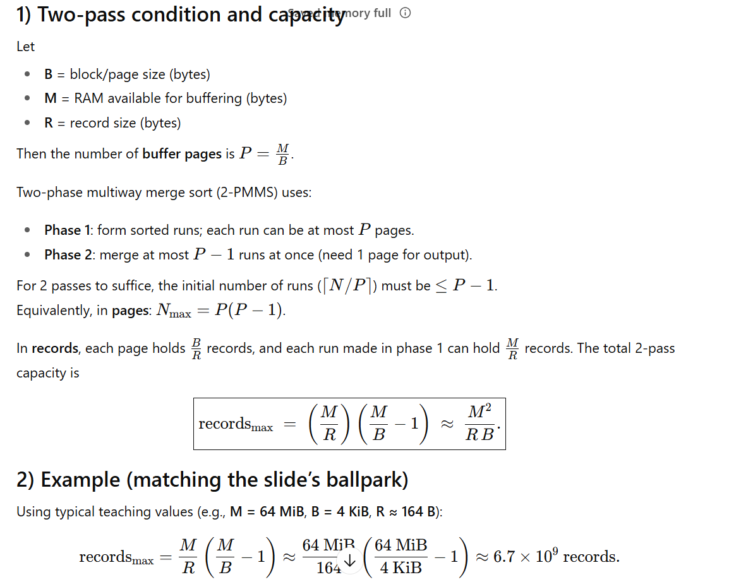
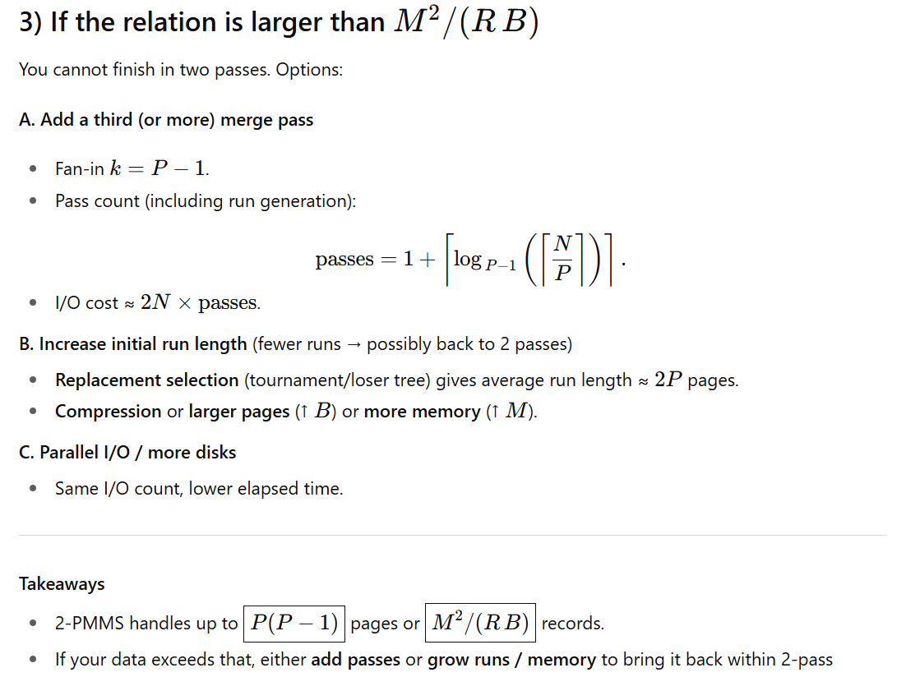

🧾 Summary
Topic | Key Takeaways
Storage Types | Primary (fast, volatile), Secondary (persistent, slower), Tertiary (archival)
Performance Bottleneck | Disk I/O is slow — optimize reads/writes and buffer usage
Sorting Challenge | In-memory sorts fail for large data; need disk-friendly algorithms
2PMMS Algorithm | Efficient two-phase approach minimizes disk I/Os
Scalability Formula | Maximum sortable records = M^2/R⋅B

🧠 Flashcards
Use these for spaced repetition!

Flashcard 1
Q: What makes primary storage volatile?
A: It loses its contents when the power is turned off.

Flashcard 2
Q: How does SSD compare to HDD in terms of speed and cost?
A: SSDs are faster but more expensive per GB than HDDs.

Flashcard 3
Q: Why can't databases work directly on secondary storage?
A: CPUs require data in main memory to process it.

Flashcard 4
Q: What is a block in storage systems?
A: A fixed-size unit (e.g., 4 KB) of data transfer between memory and storage.

Flashcard 5
Q: What is the main goal of buffer management in DBMS?
A: To reduce the number of costly disk I/O operations.

Flashcard 6
Q: What is the first phase of 2PMMS?
A: Load, sort, and write sorted sublists from main memory to disk.

Flashcard 7
Q: How many input buffers are used in Phase 2 of 2PMMS?
A: One for each sorted sublist.

Flashcard 8
Q: What is the formula for the maximum number of records 2PMMS can sort?
A: M^2/R⋅B, where M = memory size, R = record size, B = block size.

🎓 Advanced Practice Problems

🔹 Problem 1: Buffer Design Optimization
Scenario:
You have a 2PMMS sorting setup with the following specs:
- Memory available: 80 MB
- Block size: 4 KB
- Record size: 200 bytes
- The dataset is 5 GB in size.
Question:
a) How many sorted sublists will be created in Phase 1?
b) Is a two-phase merge sort sufficient, or do you need an extra pass?

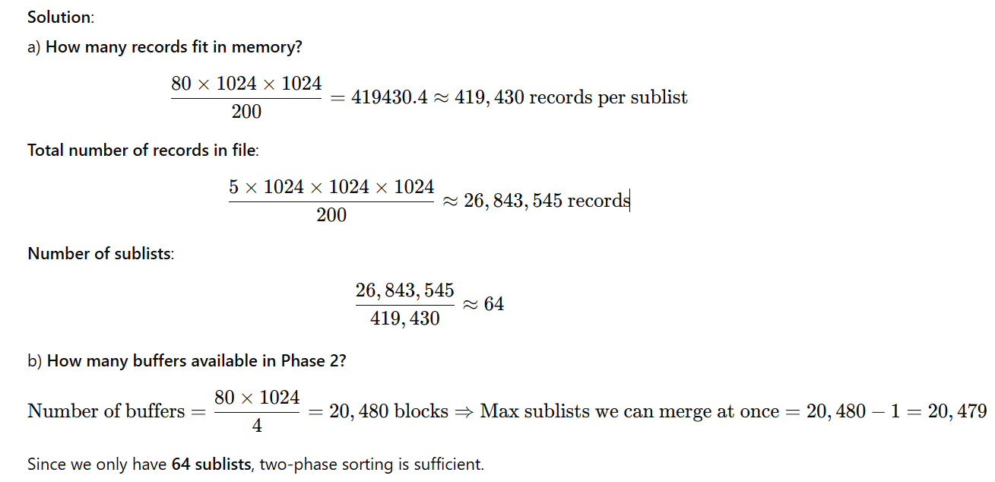

🔹 Problem 2: Disk I/O Cost Comparison
Scenario:
You’re evaluating two sorting strategies for a large file:
- Naive Merge Sort: Each record is read/written log₂n times
- 2PMMS: Each record read/written exactly twice (4 I/Os per block)
Setup:
- File size: 10 GB
- Block size: 4 KB
- Number of records: 50 million
- Main memory: 64 MB
Question:
Estimate the total number of I/Os saved by using 2PMMS instead of naive merge sort.

Solution:
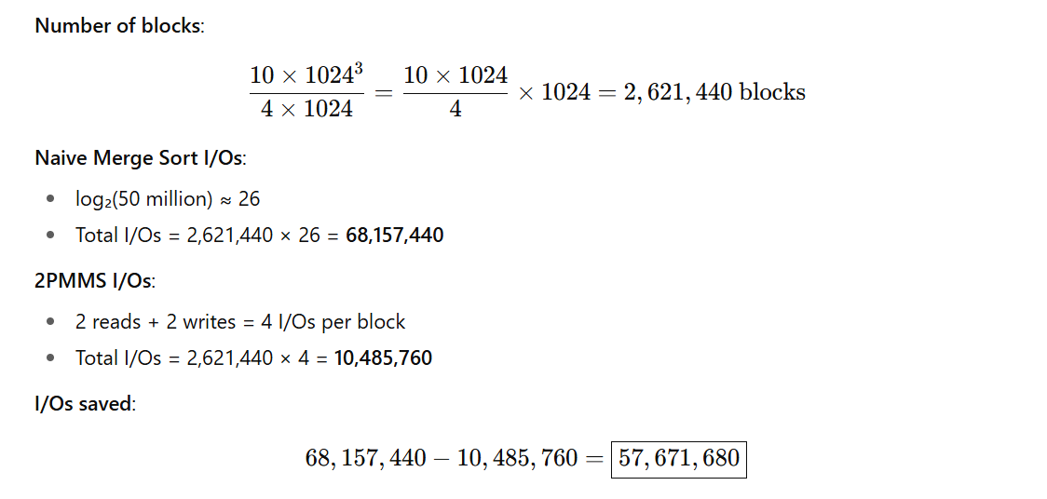

🔹 Problem 3: Multi-Pass Merge Sorting
Scenario:
You have a DBMS setup with the following specs:
- Memory = 32 MB
- Block size = 8 KB
- Record size = 256 bytes
- Dataset size = 30 GB
Question:
How many passes are required in total if you use a generalized multi-pass merge sort, assuming memory is not enough for all sublists in the second phase?

Solution: 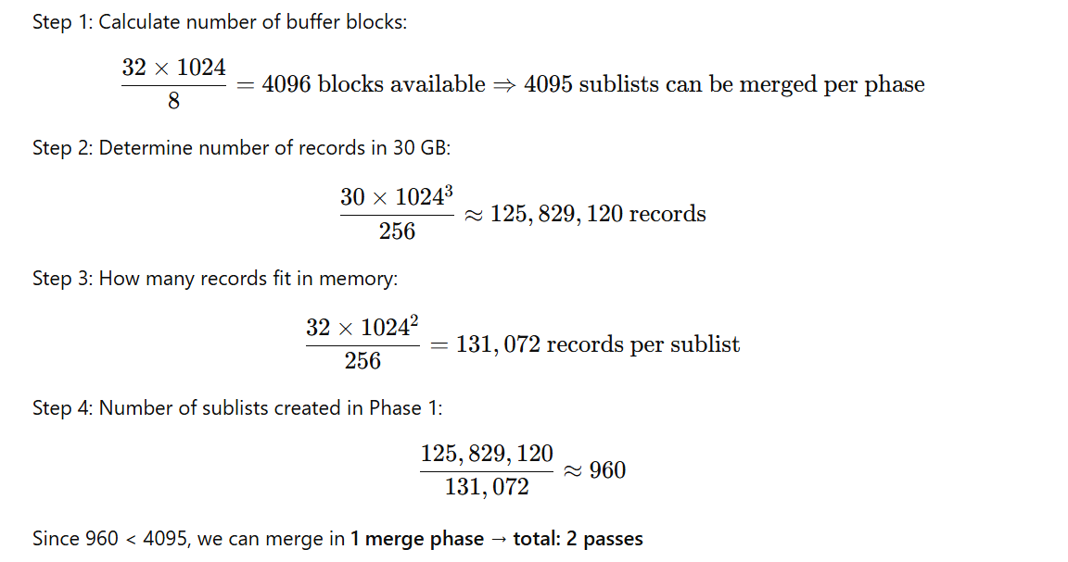

🔹 Problem 4: Design Challenge
Scenario:
You're tasked with designing a sorting system for 200 million records, each 150 bytes in size.
You can only use 24 MB of main memory and the block size is 4 KB.
Question:
a) Can 2PMMS handle this file in 2 passes?
b) If not, how many passes would be required using a multi-pass approach?

Solution:
Step 1: Total number of records = 200,000,000
Memory size = 24 MB = 25,165,824 bytes
Record size = 150 bytes
Block size = 4 KB = 4096 bytes
a) Records per sublist:
25,165,824 /150 = 167,772

  - 200,000,000 /167,772 =1,192
Blocks in memory:
✅ 1192 < 6143 → Yes, 2PMMS is sufficient

